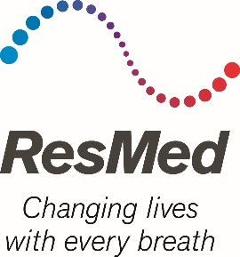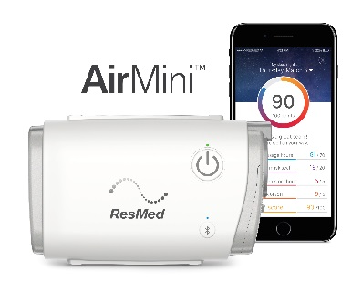

AirMini: Patient Testimonial Quotes & Medical Claim Sources

What patients are saying about AirMini:

“As a healthcare professional and a person with sleep apnea I am in love with the AirMini. Traveling with my CPAP machine has been a hassle, not to mention the extra weight the machine weights. I look forward to being able to carry my AirMini in my purse. I cannot wait until I am able to purchase the machine from my durable medical provider.”
–Vickie B., Green Bay, Wisconsin

“There was little maintenance; just snap it on and you’re good to go. And the ease of use with the [HumidAir™] waterless humidification piece, versus pouring the water in and cleaning it out – that was the cat's meow.”
–Vickie B., Green Bay, Wisconsin

“I love how compact it was; that's so nice – the size of an eyeglass case. To hook up the hose was very easy, too; I put together like ‘ba-da-boom, ba-da-bing’; it was done.”
–Jeffrey Cappello, Avon, New York

“The AirMini was a great benefit while I was traveling. The comfort of not having to pack up my home machine each time I would leave at 4:30 in the morning was a huge relief. I was able to have it packed the night prior and just heading out for a few days’ travel, and being small enough to fit in my backpack as opposed to having to carry a small case around was pleasing as well. I will be sure to obtain one when they come to market.”
–Brian Medeiros, Eldred, Pennsylvania

“I love the AirMini! It is very small and easy to use. Plus I really like the feature where you just put the mask on and it turns on. That was very cool. Sleep apnea will not stop me from traveling, whether it is a quick weekend trip or a visit in another country, and products like the AirMini make that possible for me!”
–Dustin Martzke, Shawano, Wisconsin

HMEs are talking about it, too!

“There is huge demand for a CPAP that’s easier to travel with. Not only have my patients asked me for it, they already trust the therapy they get from ResMed, so I know AirMini is going to be hugely popular. It’ll benefit my traveling patients as well as our business.”
–Samantha Romsos, respiratory therapist at HME Home Medical in Green Bay, Wisconsin

Sources for medical facts in the media release “ResMed Unveils AirMini – the World’s Smallest CPAP”

- 100 million people worldwide have sleep apnea.
  - World Health Organization 2007

- 65% of CPAP users said size is the #1 reason they don’t take their devices every time they travel.
  - ResMed internal study of 299 PAP users in the United States, conducted in April 2017.

- Half of all CPAP users don’t take their devices every time they travel.
- ResMed internal study of 288 PAP users in the United States, conducted in May 2016.

- Not treating sleep apnea may raise one’s risk of developing type 2 diabetes.
- Wang X et al. Respirology 2013

- Not treating sleep apnea may raise one’s risk of developing heart failure.
- Shahar E et al. Am J Respir Crit Care Med 2001

- Tracking one’s own PAP data via telemonitoring technology is shown to increase compliance and health outcomes.
- PricewaterhouseCoopers. Empowering the sleep apnoea patient: A study of how myAir users behave better. 2016
- Crocker M et al. A propensity-adjusted comparative analysis of PAP adherence associated with use of myAir. CHEST (Suppl.) 2016

- The AirFit N20 nasal mask was found to fit 99 percent of patients.
- ResMed AirFit N20 internal global fitting study of 159 existing ResMed patients, conducted November 12, 2015; ID A3697629

- The AirFit F20 full face mask was found to fit 97 percent of patients.
- ResMed internal study of 22 existing ResMed patients, conducted between April 26–May 27, 2016, comparing the market-leading mask with AirFit F20. Preliminary patient study – data on file; ID A3810791.
- ResMed AirFit F20 internal fitting study of 27 ResMed and non-ResMed patients, conducted between March 30–April 04, 2016. Preliminary patient study – data on file; ID A3751086.
- ResMed AirFit F20 internal international fitting study of 34 ResMed and non-ResMed patients, conducted between April 11–15, 2016. Preliminary patient study – data on file; ID A3774922.
- ResMed AirFit F20 internal international fitting study of 90 ResMed and non-ResMed patients, conducted between June 6–22, 2016. Preliminary patient study – data on file; ID A3830701

# # #

