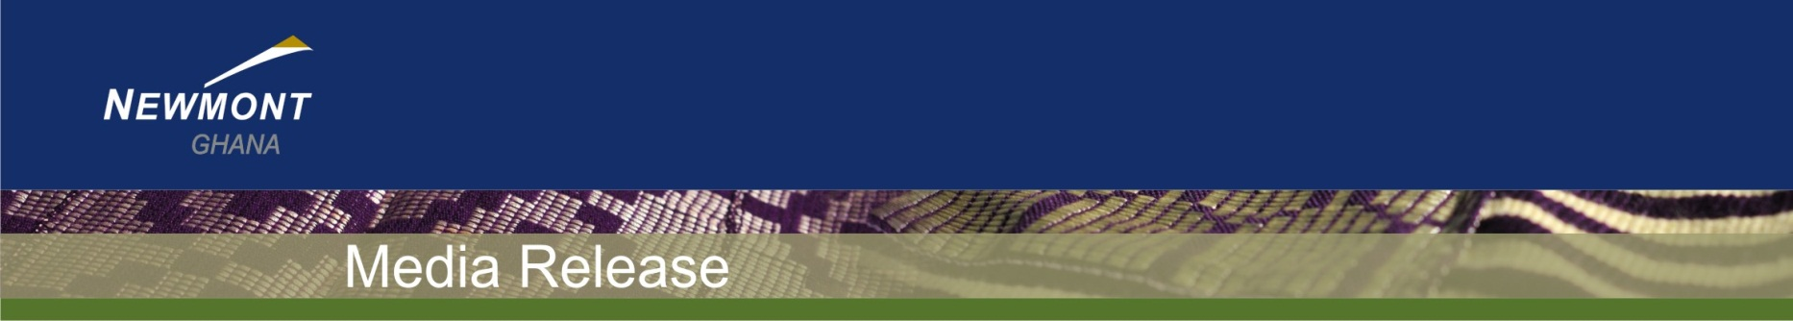

Media Statement

Newmont Ghana remains committed to honouring obligations with Akyem’s stakeholders
Company urges return to good-faith dialogue to resolve issues

New Abirem, 24th July, 2018 – Newmont Ghana reiterates its commitment to honouring its obligations with stakeholders near its Akyem operation in full compliance with the Ghana’s Mining and Minerals Law regarding compensation and land access, as well as international best practices. The company also appealed to the section of community farmers seeking new and additional land and crop compensation to resume the mediation process to achieve mutually acceptable outcomes.
“As much as we respect the right of all stakeholders to publicly express concerns, we believe good-faith dialogue is the most effective, responsible and fastest way to resolve issues,” said Daniel Egya-Mensah, Acting General Manager – Akyem Mine. “We remain open to addressing stakeholders’ concerns through direct, face-to-face discussions while publicly releasing the outcomes.”
The Company has been in a mediation process with the concerned parties, led by an independent arbitrator. The group decided to embark on their demonstration despite the ongoing mediation effort.
Newmont Ghana will continue to focus on partnering with its host communities and stakeholders to improve lives and create long-term value through sustainable and responsible mining.

Background
Some farmers within the Akyem mine area recently notified the Police of their intention to demonstrate against Newmont. The group is seeking new and additional payments for ground rent and compensation related to land access before construction of the mine, and to help press their demands on alleged building cracks from mine pit blasting.
Before Akyem’s operations began in 2013, with the input of a reputable community valuer, Newmont negotiated rates for crops, deprivation of land use and immovable structures over a period of 10 months with mine area farmers. In line with relevant minerals and mining law provisions in Ghana, an agreement was reached and signed between the Company and local farmers. The negotiated compensation rates formed the basis for full and final compensation paid to more than 2,000 farmers and landowners.
Ground rent
Ghana’s Minerals and Mining Law mandates paying ground rent to land owners affected by Akyem’s mining operations. Under the Office of the Administrator of Stool Lands Act, ground rent for stool Lands is to be paid to the Office of the Administrator of Stool Lands (OASL) for disbursement. Newmont, therefore, pays the Akyem Mine ground rent to the OASL, as required by law. This is in line with the provisions of the OASL Act as these lands fall within the Akyem Kotoku paramountcy lands.
Blast allegations
The Inspectorate Division of the Minerals Commission’s (IDMC) investigations into the alleged impact of the mine on community buildings has demonstrated that the Akyem blast overpressures and vibrations are within the legally permitted threshold.
The IDMC requested that Newmont amicably settle the community complaints. Following this request, a joint committee was established to discuss varied options until a group of community stakeholders filed their petition with the courts. The committee’s work has been put on hold awaiting the outcome in the courts.
Employment Opportunities
More than 46 percent of Akyem’s workforce is from nearby host communities. This employment figure does not include the contractor workforce which is at 49 percent. Additionally, to provide local youth with specialised skills tailored to the Mine’s operational needs, the company has instituted a four-year Apprenticeship programme and the one-year Learnership programme.
Several community youth members have benefitted from these programmes. Newmont’s employment policy and agreement with Akyem’s host communities ensures that all unskilled labour is sourced from the communities within the mine catchment. The company also has facilitated the participation of local youth in capacity building initiatives.
Conclusion
We are committed to realising our purpose of creating value and improving lives and will continue to partner our community stakeholders to enhance their quality of life. We look forward to engaging with our stakeholders to improve our performance and responsibly address their needs and concerns.

- End -

About Newmont Ghana
Africa is one of five core operating districts of Newmont Mining Corporation, the second largest gold company in the world (www.newmont.com). Newmont holds two gold mining operations in Ghana: the Ahafo mine in the Brong-Ahafo Region and the Akyem mine in the Eastern Region. The company currently employs approximately 5,000 employees and contractors.
Newmont is the only gold company listed in the S&P 500 index and in 2007 became the first gold company selected to be part of the Dow Jones Sustainability World Index. In 2015 and 2016 Newmont was ranked by the DJSI as the mining industry’s global leader in sustainability. In 2015, Newmont Ghana was honoured by the US Department of State’s Bureau of Economic and Business Affairs its efforts at promoting human rights and labour rights within the company and in its host communities.
Newmont’s industry leading performance is reflected through Newmont Ghana’s high standards in environmental management, health and safety for its employees and creating value and opportunity for its host communities and Newmont’s shareholders.
More information can be found in Newmont's annual sustainability report, www.BeyondTheMine.com. The report is published as part of Newmont’s ongoing obligations as a founding member of the International Council on Mining and Metals (www.icmm.com) and in accordance with its commitments under the United Nations' Global Compact (www.unglobalcompact.org) and the Voluntary Principles on Security and Human Rights (www.voluntaryprinciples.org).

###

Regional Media Contact: Akyem Media Contact:

Adiki O. Ayitevie  Senior Director, Communications and  External Relations  Newmont Ghana  +233 24 433 0870  adiki.ayitevie@newmont.com | Oduro-Kwarteng Marfo  Manager, Communications and External Relations  Akyem Mine  +233 24 431 1648  marfo.oduro-kwarteng@newmont.com

